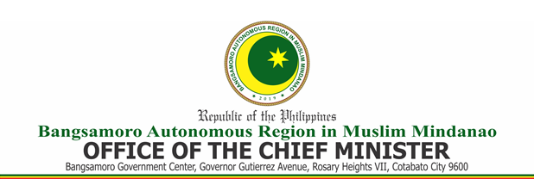

C E R T I F I C A T I O N

This is to certify that on _________________________, the Bids and Awards Committee (BAC) has awarded a contract to ____________________________ amounting to ___________________________ Pesos Only (Php ______________________________) for the procurement of _____________________________________________ through Competitive Bidding.

Issued this _____ of ______________ 2021.

______________________________________
Head of Agency/Authorized Representative

