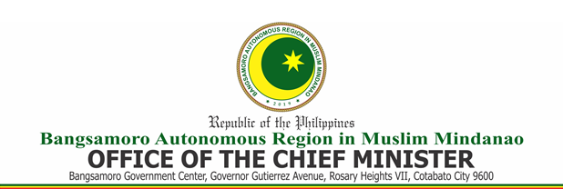

C E R T I F I C A T I O N

This is to certify that all phone calls (“and/or text messages” for mobile no.) made through (name of service provider/network) Mobile/Telephone No. ________________ under account no. ___________________ for the billing period __________________ to __________________ as shown in the attached Statement of Account were all official in nature and in connection with the activities and functions of the (requesting office/service/division/unit) of the Office of the Chief Minister – BARMM.

This certification is issued in accordance with auditing and accounting rules and regulations.

Signed this _____ day of ____________ 2021.

____________________________________
Head of Requesting Office/ service/division/unit

